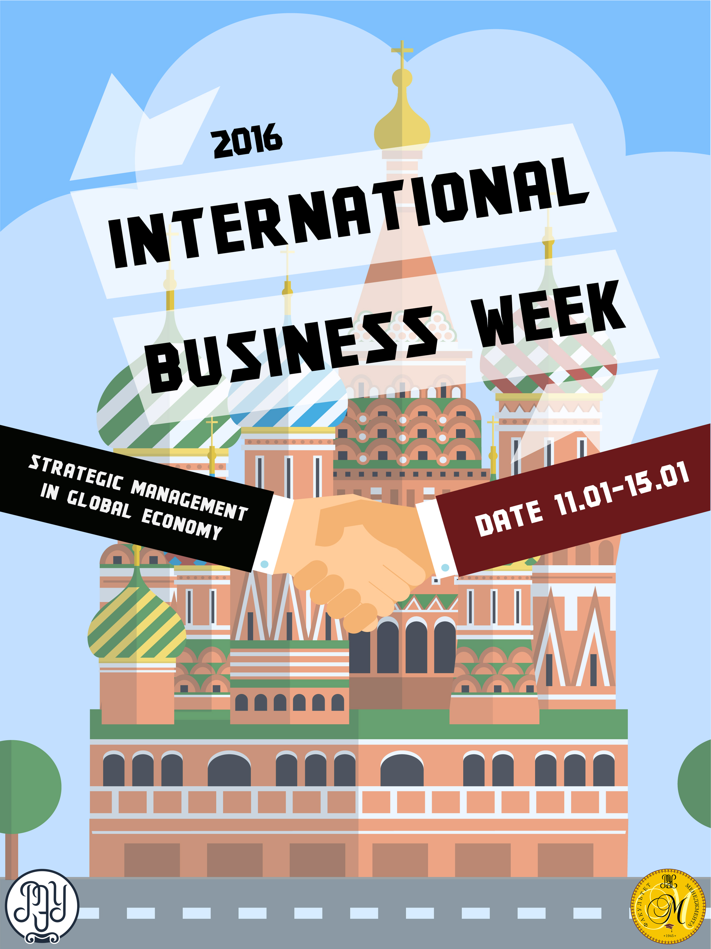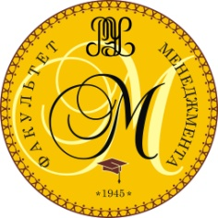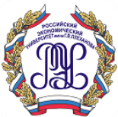

**Plekhanov Russian University of Economics**

**School of Management**

**Dear colleague!**

Every year the School of Management in Plekhanov Russian University of Economics (PRUE) organizes an International Business Week «Strategic management in global economy» for students that will be held 11 - 15 of January 2016.

  Registration for our Week in January will last till the 9 of November. Please fill in the attached registration forms and e-mail it back to [training.corporation@mail.ru](mailto:training.corporation@mail.ru)

The registration form for the Business week will be send out later.

  We can host about 20 international students (plus about 20 Russian students), so we need to know as soon as possible how many students are intending to participate from your university.

  There should be a decent level of English skills in order to take part in the business week successfully. The students who participate in the business week should have a TOEFL IBT score of at least 80 points or IELTS score of at least 6 points.

We invite you to take part in the **IV Business Week «Strategic Management in global economy»**

The cost of the week will be 200 Euro for one student and there is no need to  
use bank transfer because the payment can be made in PRUE.

Please find more information about Week: **www.rea.ru**

**Venue**: Moscow, Stremyanny lane, 36, Plekhanov Russian University of Economics.

**Language**: English.

Participants invited: **students of bachelor and master programs**

All accompanying teachers will be involved in the programme as coaches and jury members.

The main objective of this Business Week is to create an international learning environment for students and to increase their cultural awareness. Students will work together in international teams.

  We hope to see you and your students in January, here in Moscow!

**Dean**

**of the School of Management**

**of PRUE**

**PhD (Economics)**

**M. Ponomarev**

**International business week 11-15 January 2016**

***Preliminary program***

|  |  |  |
| --- | --- | --- |
| **Activity** | **Comments** | |
| **(10.01.2016 Sunday)** | | |
| Arrival | | |
| **Free program** | | |
| **Day 1 (11.01.2016 Monday)** | | |
| Breakfast | | |
| **Opening ceremony** | * Welcome speech * Master class on case analysis * Tour over Plekhanov Russian University of Economics | |
| Lunch | | |
| **Team work** | Students will be grouped into 4-5 international teams of 5-6 person. Each team will have a coordinator (student) who will accompany them over the university. During the work faculty members will drop in to provide assistance to the teams. | |
| **Cultural programme:**   * **bus –trip** * **walk tour** | The students will be picked up by the university bus and driven to Arbatskaya street where they will have a walk tour over the street and do sightseeing. University students and officers will accompany the international students.  Later the university bus will take the group back to the University. | |
| Dinner | | |
| **Day 2 (12.01.2016 tuesday)** | | |
| Breakfast | | |
| **Visit to a Russian company (SAP)** | Participants will be accompanied to the company by our international coordinator. The company is located in 15 min. walk from the University. | |
| Lunch | | |
| **Team work** | | |
| **Free program** | | |
| **Day 3 (13.01.2016 wednesday)** | | |
| Breakfast | | |
| **Visit to a Russian company (Rosatom)** | Participants will be accompanied to the company by our international coordinator  There will be a university bus picking up students. | |
| Lunch | | |
| **Team work** | | |
| **Free program** | | |
| **Day 4 (14.01.2016 thursday)** | | |
| Breakfast | | |
| **Team work on final presentations** | | |
| Lunch | | |
| **Meeting with members of Plekhanov University Student Union** | | Free time for international students and for Russian students to communicate. |
| **Day 5 (15.01.2016 friDAY)** | | |
| Breakfast | | |
| **Team work on final presentations** | | |
| Coffee break | | |
| **Final presentation** | | Jury will consist of:   * 3 professors of Plekhanov Russian University of Economics * 1 representative of the administration of School of Management * International coordinators of guest universities * 1 representative of SAP |
| Lunch | | |
| **(16.01.2016 Saturday)** | | |
| **Departure of participants** | | |

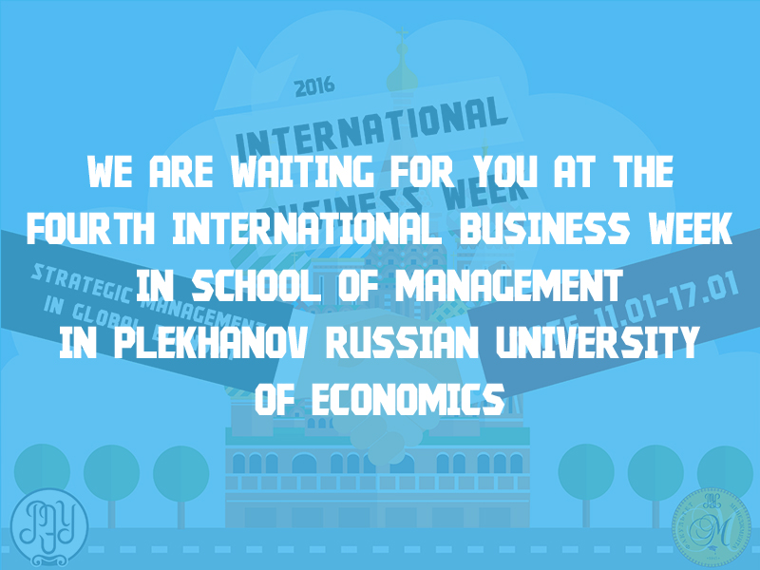

**Organizing committee:**

117997, Moscow, Stremyanny lane, 36, Plekhanov Russian University of Economics, building 2, room 334. Tel.: +7 (499) 237-85-10, e-mail: [training.corporation@mail.ru](mailto:training.corporation@mail.ru), Busalova Aglaya